Assignment 5: Design (Multi-Layer) Sequence Diagrams

Yilong Yu – Ben Powers – [Jaehyun](javascript://) Park

8170995 – 7986250 – 8105702

Systems Analysis and Design / INFO2320

[David Turton](https://conestoga.desire2learn.com/d2l/le/content/229806/viewContent/4630975/View) / [Sachin](javascript://) Parikh

November 28th, 2018

Team Name: Scooby-doo Teacher Name: [Sachin](javascript://) Parikh Due: Nov 28, 2018 6:00 PM

Systems Analysis & Design – Assignment 5:

Design (Multi-Layer) Sequence Diagrams

You are working with the case **Spring Breaks ‘R’ Us** (**SBRU**) Travel Service. The four major subsystems of the solution being proposed are:

* Resort Relations
* Student Booking
* Accounting & Finance
* Social Networking

Chapter 13 Questions – (page 441)

Refer to your Design Class Diagrams from assignment 4 and the Use Cases from assignments 1 & 3.

1. Create a multi-layer Design Sequence Diagram for the Use Case ***Book a Reservation***, including actor(s), gateways (forms), controllers, design classes and data access classes.

**Please see next page.**

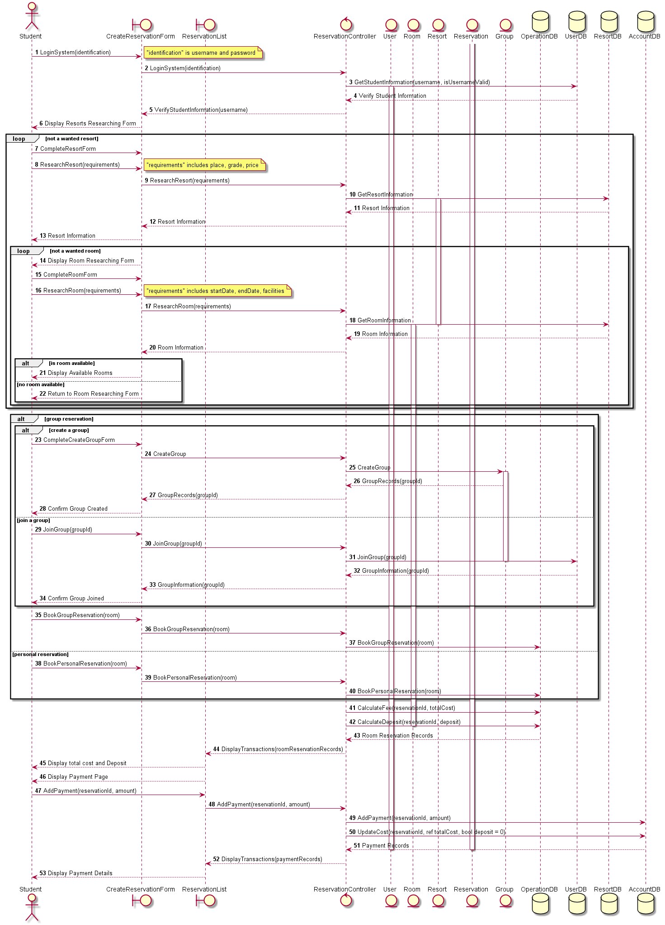

Hand In

* Zip your answers into a single file and upload it to the assignment folder on eConestoga … only have one team member upload per team.
* Hand the marking sheet in during the lab period for the week its due, with your team name, lab section number and teacher name.